**SP/RM[1,1] – Enrichment Cortland Watson**

**Type in your score here 🡪 __20__ out of 29 points possible**

1. (5 points) Ponder/Reflect Exercise – Reflect on what you have learned from this portion of the class. Examples of what you can do are: a brief outline of material covered, insights you gained from class or personal study, or items you feel that you need to follow up or work on. (3-5 sentences)
   1. This week I have learned about the power of power. By having power we are able to seek out the best way to find truth, without coming across error. By using power to find our sample size, we are able to ensure that the data that we collect will not only be significant, but also that it will represent truth.
2. We are interested in comparing 4 different methods for preparing for the ACT exam:
   1. Method A: Control-just take the exam
   2. Method B: Take one practice exam
   3. Method C: Take a prep course online
   4. Method D: Be hypnotized the day before
   5. You are interested in assessing the power of the F test (in ANOVA) for detecting differences in preparation method means when the significance level is α = 0.05.
      1. (6 points) Suppose that ACT scores have a standard deviation of 4.7, and suppose we would like to evaluate the possibility that the group means are $μ_{A}=21$, $μ_{A}=23$, $μ_{A}=25$, and $μ_{A}=27$. In R, make a plot that shows the power of the F test when n = 2, 3,…, 20. Note: after using the power.anova.test command in R for every sample size, do the following: (Print and include this plot with your homework.)
         1. 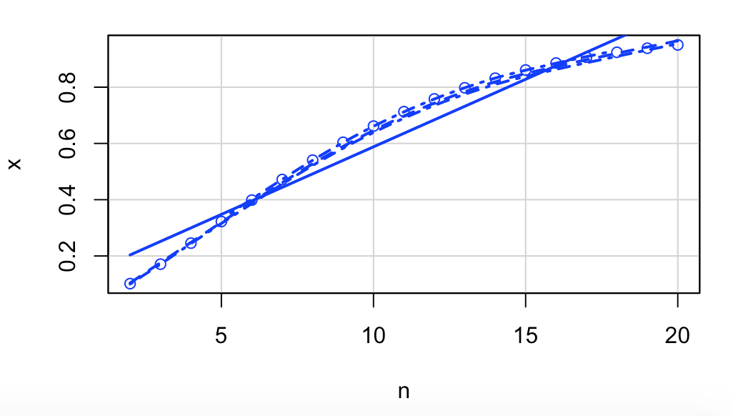
      2. (2 points) What is the smallest value for the group size (n) that gives 80% power?
         1. N = 13
      3. (4 points) What happens to your power curve if your hypothesized means are $μ_{A}=21$, $μ_{B}=21$, $μ_{C}=21$, and $μ_{D}=27$? Explain this at a level of an FDMAT 22x student.
         1. 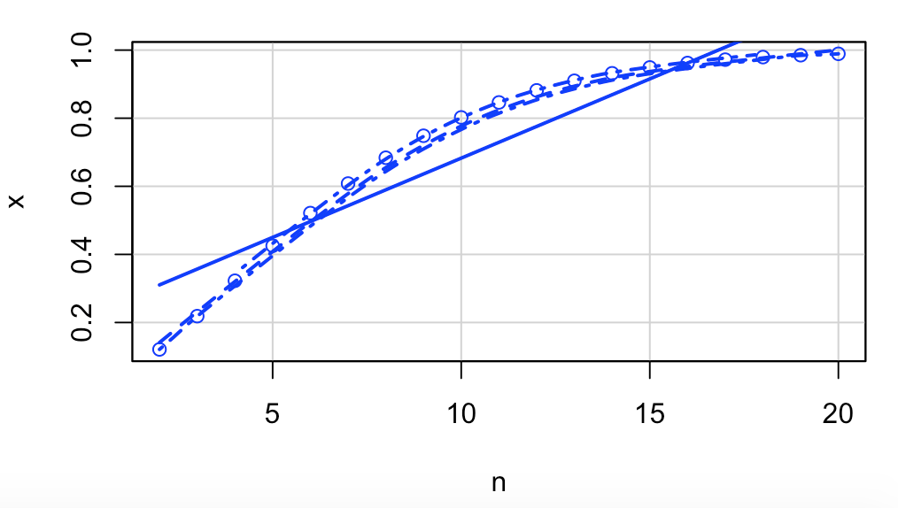
3. The figure below illustrates issues related to the power of hypothesis tests in ANOVA. The top picture refers to the null hypothesis and the bottom picture refers to the alternative hypothesis.
   1. 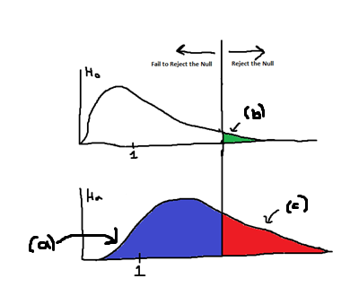
   2. (1 pt) What is the name of the distribution labeled (a)? F-distribution
   3. (1 pt) What is the name for the area marked as (b)? alpha (type 1 error)
   4. (1 pt) What is the name for the area marked as (c)? power
4. In this problem, you will use SAS or R to do a complete analysis of variance on the head injury severity scores associated with 7 types of cars. The data are found in the file headinjury.csv (note that it is comma-delimited) or SAS filename *headinjury*
   1. (9 points) Do the analysis, assuming that instead of looking at all the pairwise comparisons, you only want to consider 3 different contrasts:
      1. mean of the pickups&vans&minivans minus the mean of the other 4 car types,
      2. mean of the heavy&medium cars minus the mean of the light&compact cars, and
      3. mean of light cars minus mean of compact cars.